Computer Science

Manchester Metropoliten University

Mahmoud SHneb

Contents

Introduction 2

Multiple Classes 2

Constructors 2

Methods 2

Public/private 2

Inheritance Super 3

Meaningful Variable names 3

constants - appropriate use 3

Use of Functions 3

Switch case – game mode 4

polymorphism – Array List 4

Enum set – game modes 4

Concise efficient code 5

# Introduction

This game is made using processing3 in Java. This file contains the Coding concepts that been used to create this game.

# Multiple Classes



9 classes used to create this project. In each class is an object and collection of similar functionalities. For example, the background class has the background image, the timer, the different splash screens, etc. a different class was unnecessary as might complicate the code.

# Constructors



Each class has 1 constructor with appropriate parameters.

# Methods



Methods are used wherever appropriate for a specific object.

# Public/private



Public is used for the universal values like health and score. Private is used for the variables that only belong to that class.

# Inheritance Super



Inheritance is used for the collectables. The parent class is gold and then money and health potion added which meat to behave a same. However, the void render is been overridden so they display different animated characters.

# Meaningful Variable names



Meaningful variable names are used to simplify the code and make it understandable as the lines of code increase.

# constants - appropriate use



Constants are used for loading images using a for loop.

# Use of Functions



# Switch case – game mode

# polymorphism – Array List



# Enum set – game modes



# Concise efficient code

I used for loop to load the images instead of loading each image separate. And it helps loading a lot of images.

For the buttons I used photoshop to design it in the same style of the game to save time due to my prior experience in photoshop. So instead of loading each button in a sperate code and cause repeated code to a certain extent. I made the image name a variable string so I can call it within the constructer in the main page. Using an index array, I can create as many buttons as I need.

# Sound

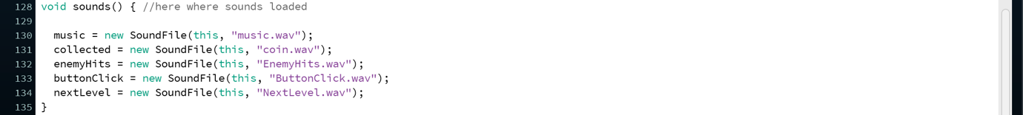

I’ve used sounds as affects for collusion and buttons presses.